A PROJECT REPORT
ON
HAND GESTURE CONTROLLED
VIRTUAL MOUSE USING ARTIFICAL INTELLIGENCE

Submitted in partial fulfillment of the requirements for the degree of the

DIPLOMA
IN
COMPUTER ENGINEERING

Submitted by

C.SHIVA CHARAN REDDY 22235-CS-038

Under the esteemed guidance of
AYESHA TARANNUM LECTURE


DEPARTMENT OF COMPUTER ENGINEERING
INDUR INSTITUTE OF ENGINEERING AND TECHNOLOGY PONNALA (V), SIDDIPET, SIDDIPET (DIST) – 502 27

INDUR INSTITUTE OF ENGINEERING AND TECHNOLOGY
PONNALA (V), SIDDIPET, SIDDIPET (DIST) – 502 277
CERTIFICATE

”HAND GESTURE CONTROLLED VIRTUAL MOUSE USING
ARTIFICIAL INTELLIGENCE”
Submitted By
C.SHIVA CHARN REDDY 22235-CS-038

For partial fulfilment of the academic requirements for the award of
Diploma in Computer Engineering to the Indur Institute of Engineering and Technology, Ponnala(V), Siddipet(Dist), Telangana affiliated to
State Board of Technical Education & Training was carried out by them
under the guidance and supervision

Project guide Head of the section
AYESHA TARANNUM E.SUNITHA
(Dept of CSE) (Dept oCSE)
EXTERNAL SIGNATURE

ACKNOWLEDGMENT

Determination and dedication with sincerity and hard work will lead to the height of success.
In spite of the obstacles faced, the valuable suggestions and their best wishes helped us
to complete project titled “HAND GESTURE CONTROLLED VIRTUAL MOUSE USING ARTIFICAL INTELLIGENCE” successfully.
As a mark of gratitude, we express my gratitude and special thanks to AYESHA TARANNUM Project guide helped us for giving valuable suggestions and guidance throughout the completion of project.
We are highly indebted to E.SUNITHA, Head of the department of computer
engineering for his unusual co-operation during the course of the project. We express our special thanks to Dr.V.P.RAJU, principal for providing kind environment for the completion of the project.
Finally, we would like to thanks to the people who have helped us directly or indirectly in Completion of the project.
Thank you one and all…

DECLARATION

We hereby declare that the entire project work embodied in this dissertation entitled

“HAND GESTURE CONTROLLED VIRTUAL MOUSE USING ARTIFICAL
INTELLIGENCE” has been independently carried out by our knowledge and no part of this work has been submitted for any degree/diploma in any institution or university previously.

C.SHIVA CHARAN REDDY 22235-CS-038

ABSTRACT
Recent improvements in gesture detection and hand tracking have brought about both opportunities and challenges. Try out a few of these options while outlining challenges and exciting future possibilities for virtual reality and user engagement.
The use of hand gesture recognition in controlling virtual devices has become popular due to the advancement of artificial intelligence technology. A hand gesture-controlled virtual mouse system that utilizes AI algorithms to recognize hand gestures and translate them into mouse movements is proposed in this paper. The system is designed to provide an alternative interface for people who have difficulty using a traditional mouse or keyboard. The proposed system uses a camera to capture images of the user’s hand, which are processed by an AI algorithm to recognize the gestures being made. The system is trained using a dataset of hand gestures to recognize different gestures. Once the gesture is recognized, it is translated into a corresponding mouse movement, which is then executed on the virtual screen. The system is designed to be scalable and adaptable to different types of environments and devices. All the input operations can be virtually controlled by using dynamic/static hand gestures along with a voice assistant. In our work we make use of ML and Computer Vision algorithms to recognize hand gestures and voice commands, which works without any additional hardware requirements. The model is implemented using CNN and mediapipe framework. This system has potential applications like enabling hand-free operation of devices in hazardous environments and providing an alternative interface for hardware mouse. Overall, the hand gesture-controlled virtual mouse system offers a promising approach to enhance user experience and improve accessibility through human-computer interaction.
The evolution of human-computer interaction (HCI) seeks more intuitive and accessible methods for users to interact with technology. Traditional input devices like the mouse and keyboard, while effective, can sometimes hinder seamless user experiences, particularly for individuals with physical limitations. This paper presents a novel approach to HCI through the
Development of a gesture-controlled virtual mouse using hand tracking technology. Leveraging advanced computer vision and deep learning techniques, the system captures and interprets hand gestures in real-time to control cursor movements and execute mouse functions such as clicking, dragging and other functions etc . The proposed system utilizes a standard camera to detect hand movements, employing convolutional neural networks (CNNs) for hand detection and key point extraction. These key points are processed and classified into specific gestures using machine learning algorithms, which are then mapped to corresponding mouse actions, providing a natural and efficient interface for users.

CONTENTS
PAGE NO ACKNOWLEDGEMENT 03

ABSTRACT 04 CHAPTER NAME

1. INTRODUCTION 09-13
1.1 Project Overview 10
1.2 Objective 11
1.3 Existing System 12
1.4 Proposed System 13

2. SYSTEM REQUIREMENTS 15-30
2.1 Introduction 16-21
2.1.1 Mechanical Mouse
2.1.2 Optimal And Laser Mouse
2.1.3 Problem Statements
2.1.4 Motivation Of virtual Mouse
2.1.5 Convenient
2.1.6 Cost Effective
2.1.7 Project Scope
2.1.8 Project Objective
2.1.9 Impact,Significance And Contribution
2.1.10 Literature review
2.1.11 Visual Panel
2.2 Performance Requirements 22
2.3 Analysis Model 23-24
2.3.1 Problem Definition

2.4 Feasibility Study 25
2.5 Technical Feasibility 26-28
2.6 System Analysis 29
2.7 Software Required 30

3. SYSTEM DESIGN 31-38
3.1 System Architecture 32
3.2 Activity Diagram 33
3.3 ER Diagram 34
3.4 Performance Analysis Diagram 35
3.5 Methodology And Modules 36
3.6 Custom Instruction 37-38
4. IMPLEMENTATION 39-51

5. SYSTEM TESTING 52-53
5.1 Types of Tests
5.1.1 Unit Testing
5.1.2 Integration Testing
5.1.3 System Testing
6. RESULTS 54-59

7. CONCLUSION 60-61

8. REFERENCES 62-63

LIST OF ABBREVATIONS
AI  HCI  ML  UI  GUI  CPU  GPU  CV  DSP  SVM | Artificial Intelligence  Human-Computer Interaction  Machine Learning  User Interface  Graphical User Interface  Central Processing Unit  Graphics Processing Unit  Computer Vision  Digital Signal Processing  Support Vector Machine Matrix
MATLAB | Laboratory  Computed Tomography  Operating System  Red-Green-Blue  Optical Character Appreciation  Deoxyribonucleic Acid
CT OS
RGB
OCR
DNA
ATR

Automatic Target Recognition

CHAPTER – 1 INTRODUCTION

1.1 Project Overview
HAND GESTURE CONTROLLED VIRTUAL MOUSE USING ARTIFICIAL

INTELLIGENCE

The Hand Gesture Controlled Virtual Mouse is an innovative concept that encompasses different types of interactions using gestures to control a computer system. This system uses Artificial Intelligence (AI) techniques for hand gesture recognition and control.

Gesture control technology includes the use of hand tracking algorithms, computer vision, and machine learning models that can detect and interpret hand movements. Tools like Mediapipe, OpenCV, and specialized software are utilized to implement this gesture recognition system. It can involve real-time tracking and movement of the hand, enabling mouse functions like click, drag, and scroll through simple gestures.

The Virtual Mouse allows users to control their computer or applications without physical contact with a traditional mouse. The advantage of this system over conventional methods is the freedom it provides for touchless control, which can be useful in hygiene-sensitive environments or for those with physical limitations. The system reduces reliance on hardware peripherals and brings innovation to human-computer interaction.

This system is particularly aimed at enhancing accessibility and creating a more immersive user experience. With high accuracy and security in interpreting gestures, cases of input errors are minimized. The hand gestures are processed using AI models, which can be queried to perform specific mouse actions.

With the **Hand Gesture Controlled Virtual Mouse**, users can utilize their computer easily through gestures without the need for a physical mouse. The system is designed to track users' hand movements precisely, providing seamless interaction with their computer.

The initial setup requires the user to calibrate the system for their specific gestures. This registration phase ensures that the system can accurately interpret hand movements before regular usage begins.

1.2 Objective

The specific objectives of the project include:
- Reviewing the existing/current method of mouse control using physical devices in various systems and applications;
- Developing an automated virtual mouse system controlled through hand gestures using AI technology;
- Implementing the hand gesture-controlled virtual mouse system to enhance humancomputer interaction;
- Validating the system to ensure accurate detection of hand gestures and smooth execution of mouse functions.
This project is being developed using **Python with tools like OpenCV, Mediapipe, and Autopy**, with **AI-based gesture recognition** for functionality. The data related to hand gestures and movements will be processed in real time, ensuring precise control. In case of any system failure, backup solutions are incorporated to restore previous settings. The software design ensures that users can access all mouse functionalities effortlessly, requiring just a simple hand movement to navigate, click, or scroll across the screen.

1.3 Existing System

The current system of mouse control predominantly relies on **physical devices like traditional mice**. Users operate these devices to interact with the computer by moving the cursor, clicking, scrolling, or dragging objects on the screen. The mouse is physically connected to the computer via USB or wirelessly using Bluetooth, and it converts the user's physical movements into digital actions on the computer screen.
Disadvantages of the Existing System:
- Physical Hardware Dependency: The user is entirely dependent on a physical mouse, which can **limit accessibility**, especially for people with disabilities or those in specific environments (e.g., healthcare settings where touchless systems are preferred).

- Limited Flexibility: The traditional mouse provides only limited forms of interaction, as it relies solely on **direct physical input**, which may not be suitable for more intuitive or immersive computing experiences.

- Prone to Hardware Issues: Mice can suffer from **hardware malfunctions**, including issues with the sensor, buttons, or connectivity, which can disrupt the user experience.

- Reduced Accessibility: People with physical limitations may find it **difficult or impossible to use a traditional mouse**, making the system less inclusive for all types of users.

- Lack of Intuitive Controls: The mouse’s **linear movements** do not take full advantage of more intuitive, modern interaction methods like **gestures or voice commands**, which can offer more natural ways of controlling a computer.

- Maintenance and Costs: Physical mice require **maintenance** and **replacement over time**, adding costs and effort to the process of using this method of control.

The limitations of the existing physical mouse system open the door for more advanced and intuitive solutions like a **hand gesture-controlled virtual mouse**, which can provide a more flexible, accessible, and innovative user experience.

1.4 Proposed System
The **"Hand Gesture Controlled Virtual Mouse"** is an innovative, touchless interface system that allows users to control their computer through simple hand movements. In this system, users no longer need a physical mouse to interact with their computer. Instead, the system relies on a **camera and hand gesture recognition algorithms** to track the user's hand movements and perform mouse functions like moving the cursor, clicking, scrolling, and dragging.

The system maintains a database where configurations related to specific gestures and user preferences are stored. This database ensures that the system adapts to each user’s unique gestures and provides a smooth, customizable experience.

In the **"Hand Gesture Controlled Virtual Mouse"**, users can interact with their computer with ease by simply using gestures. Before using the system, users may need to go through an initial calibration process where the system records their specific gestures and stores them in the database. The system administrator can also assist users in setting up the software and ensuring it is configured correctly.

After the calibration process, the user is ready to use the hand gesture system. The system ensures that the correct gestures are interpreted in real-time, providing seamless control over the computer. If the system is unable to detect the gestures properly, recalibration can be done.
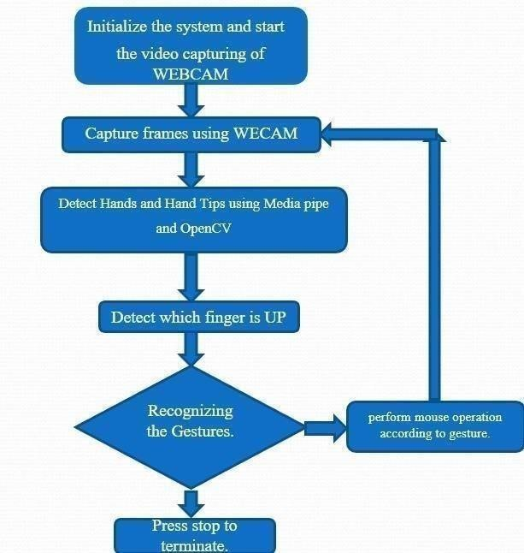

Advantages of the Proposed System:
- **Hands-free operation**, making it ideal for environments where touch-based devices may not be feasible or hygienic.
- **Increased accessibility** for users with physical disabilities, as the system requires no physical contact.
- **More intuitive and immersive** user experience by allowing control through natural hand gestures.
- **Less hardware dependency**, reducing the need for physical devices like a mouse, thereby cutting down on maintenance and costs.
- **Reduced effort and time** in maintaining physical peripherals, focusing instead on creating and managing the gesture recognition software.
- **Enhanced flexibility**, as users can control their computers from a distance and in various scenarios where using a traditional mouse might be cumbersome.
This proposed system represents a step toward more intuitive, accessible, and immersive interaction with technology

CHAPTER – 2

SYSTEM REQUIREMENTS

2.1 Introduction
The **Hand Gesture Controlled Virtual Mouse** is an innovative system that leverages hand gestures to control a virtual mouse using **Artificial Intelligence (AI)**. This system enables users to interact with their computer in a touchless manner, providing an alternative to traditional physical input devices like a mouse. Hand gesture recognition is powered by advanced computer vision technologies, which detect and interpret hand movements to perform mouse functions. Hand gesture technology includes methods like **tracking hand landmarks**, **interpreting gestures in real-time**, and **translating those gestures into specific computer commands** such as cursor movement, clicks, drags, and scrolls. The system typically involves a camera to capture the gestures and AI algorithms to process and execute the corresponding commands.

The advantage of this **gesture-based control system** over traditional methods is its ability to offer users **more flexibility** and a **hands-free experience**. It reduces the reliance on physical devices, which can be a limitation in certain environments. This system also minimizes the risk of mechanical failure and user fatigue associated with prolonged use of a physical mouse. Gesture input is directly processed and mapped to mouse actions in real-time, allowing smooth and precise control of the computer.

Additionally, gesture recognition is stored in a database, allowing the system to adjust to different users' preferences and calibrate accordingly. This increases the accuracy of hand movements and improves the overall user experience..

2.1.1. Mechanical Mouse
Known as the trackball mouse that is commonly used in the 1990s, the ball within the mouse are supported by two rotating rollers in order to detect the movement made by the ball itself.
One roller detects the forward/backward motion while the other detects the left/right motion. The ball within the mouse are steel made that was covered with a layer of hard rubber, so that the detection are more precise. The common functions included are the left/right buttons and a scroll-wheel. However, due to the constant friction made between the mouse ball and the rollers itself, the mouse are prone to degradation, as overtime usage may cause the rollers to degrade, thus causing it to unable to detect the motion properly, rendering it useless. Furthermore, the switches in the mouse buttons are no different as well, as long term usage may cause the mechanics within to be loosed and will no longer detect any mouse clicks till it was disassembled and repaired.
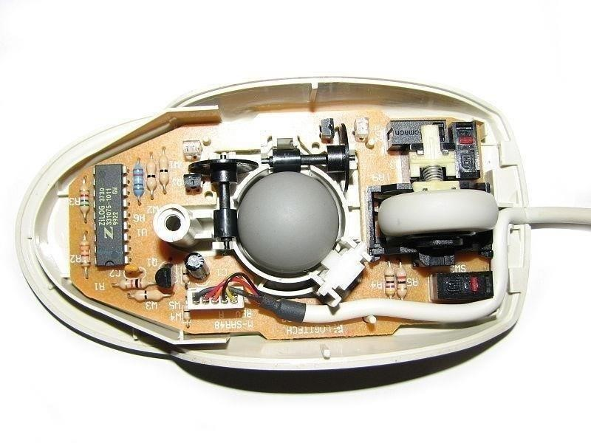
Figure 1.1 Mechanical mouse, with top cover removed

The following table describes the advantages and disadvantages of the Mechanical Mouse.
Advantage | Disadvantage
- Allows the users to control the computer system by moving the mouse.  - Provides precise mouse  tracking movements | - Prone to degradation of the mouse rollers and button switches, causing to be faulty.  - Requires a flat surface to operate.
Table 1.1: Advantage and disadvantage of the Mechanical Mouse

2.1.2. Optical And Laser Mouse
A mouse that commonly used in these days, the motions of optical mouse rely on the Light Emitting Diodes (LEDs) to detect movements relative to the underlying surface, while the laser mouse is an optical mouse that uses coherent laser lights. Comparing to its predecessor, which is the mechanical mouse, the optical mouse no longer rely on the rollers to determine its movement, instead it uses an imaging array of photodiodes. The purpose of implementing this is to eliminate the limitations of degradation that plagues the current predecessor, giving it more durability while offers better resolution and precision. However, there's still some downside, even-though the optical mouse are functional on most opaque diffuse surface, it's unable to detect motions on the polished surface. Furthermore, long term usage without a proper cleaning or maintenance may leads to dust particles trap between the LEDs, which will cause both optical and laser mouse having surface detection difficulties. Other than that, it's still prone to degradation of the button switches, which again will cause the mouse to function improperly unless it was disassembled and repaired.
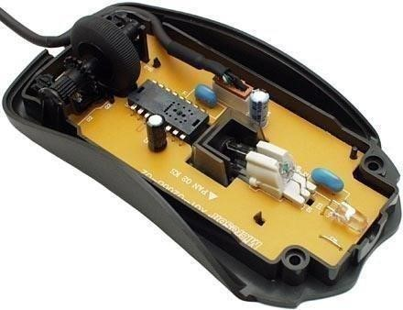
Figure 1.2 Optical Mouse, with top cover removed

The following table describes the advantages and disadvantages of the Optical and Laser Mouse.
Advantages | Disadvantages
- Allows better precision with lesser hand movements.  - Longer life-span. | - Prone to button switches degradation.  - Does not function properly while on a polished surface.
Table 1.2: Advantage and disadvantage of the Optical and Laser Mouse

2.1.3. Problem Statement
It's no surprised that every technological devices have its own limitations, especially when it comes to computer devices. After the review of various type of the physical mouse, the problems are identified and generalized. The following describes the general problem that the current physical mouse suffers:
- Physical mouse is subjected to mechanical wear and tear.
- Physical mouse requires special hardware and surface to operate.
- Physical mouse is not easily adaptable to different environments and its performance varies depending on the environment.
- Mouse has limited functions even in present operational environments.
- All wired mouse and wireless mouse have its own lifespan.

2.1.4. Motivation of Virtual Mouse
It is fair to say that the Virtual Mouse will soon to be substituting the traditional physical mouse in the near future, as people are aiming towards the lifestyle where that every technological devices can be controlled and interacted remotely without using any peripheral devices such as the remote, keyboards, etc. it doesn't just provides convenience, but it's cost effective as well.

2.1.5. Convenient
It is known in order to interact with the computer system, users are required to use an actual physical mouse, which also requires a certain area of surface to operate, not to mention that it suffers from cable length limitations. Virtual Mouse requires none of it, as it only a webcam to allow image capturing of user's hand position in order to determine the position of the pointers that the user want it to be. For example, the user will be able to remotely control and interact the computer system by just facing the webcam or any other image capturing devices and moving your fingers, thus eliminating the need to manually move the physical mouse, while able to interact with the computer system from few feet away.

2.1.6. Cost Effective
A quality physical mouse is normally cost from the range of 30 ringgit to a hefty 400 ringgit, depending on their functionality and features. Since the Virtual Mouse requires only a webcam, a physical mouse are no longer required, thus eliminating the need to purchase one, as a single webcam is sufficient enough to allow users to interact with the computer system through it, while some other portable computer system such as the laptop, are already supplied with a built-in webcam, could simply utilize the Virtual Mouse software without having any concerns about purchasing any external peripheral devices.

2.1.7. Project Scope
Virtual Mouse that will soon to be introduced to replace the physical computer mouse to promote convenience while still able to accurately interact and control the computer system. To do that, the software requires to be fast enough to capture and process every image, in order to successfully track the user's gesture. Therefore, this project will develop a software application with the aid of the latest software coding technique and the open-source computer vision library also known as the OpenCV. The scope of the project is as below:
- Real time application.
- User friendly application.
- Removes the requirement of having a physical mouse.
The process of the application can be started when the user's gesture was captured in real time by the webcam, which the captured image will be processed for segmentation to identify which pixels values equals to the values of the defined colour. After the segmentation is completed, the overall image will be converted to Binary Image where the identified pixels will show as white, while the rest are black. The position of the white segment in the image will be recorded and set as the position of the mouse pointer, thus resulting in simulating the mouse pointer without using a physical computer mouse. The software application is compatible with the Windows platform. The functionality of the software will be coded with C++ programming language code with the integration of an external library that does the image processing known as the OpenCV.

2.1.8. Project Objective
The purpose of this project is to develop a Virtual Mouse application that targets a few aspects of significant development. For starters, this project aims to eliminate the needs of having a physical mouse while able to interact with the computer system through webcam by using various image processing techniques. Other than that, this project aims to develop a Virtual Mouse application that can be operational on all kind of surfaces and environment.
The following describes the overall objectives of this project:
- To design to operate with the help of a webcam.
The Virtual Mouse application will be operational with the help of a webcam, as the webcam are responsible to capture the images in real time.
The application would not work if there are no webcam detected.
- To design a virtual input that can operate on all surface.
The Virtual Mouse application will be operational on all surface and indoor environment, as long the users are facing the webcam while doing the motion gesture.
- To program the camera to continuously capturing the images, which the images will be analysed, by using various image processing techniques. As stated above, the Virtual Mouse application will be continuously capturing the images in real time, where the images will be undergo a series of process, this includes HSV conversion, Binary Image conversion, salt and pepper noise filtering, and more.
- To convert hand gesture/motion into mouse input that will be set to a particular screen position.
The Virtual Mouse application will be programmed to detect the position of the defined colours where it will be set as the position of the mouse pointers. Furthermore, a combination of different colours may result in triggering different types of mouse events, such as the right/left clicks, scroll up/down, and more.

2.1.9 Impact, Significance and Contribution
The Virtual Mouse application is expected to replace the current methods of utilizing a physical computer mouse where the mouse inputs and positions are done manually. This application offers a more effortless way to interact with the computer system, where every task can be done by gestures. Furthermore, the Virtual Mouse application could assist the motor-impaired users where he/she could interact with the computer system by just showing the correct combination of colours to the webcam.

2.1.10. Literature Review
As modern technology of human computer interactions become important in our everyday lives, varieties of mouse with all kind of shapes and sizes were invented, from a casual office mouse to a hard-core gaming mouse. However, there are some limitations to these hardware as they are not as environmental friendly as it seems. For example, the physical mouse requires a flat surface to operate, not to mention that it requires a certain area to fully utilize the functions offered. Furthermore, some of these hardware are completely useless when it comes to interact with the computers remotely due to the cable lengths limitations, rendering it inaccessible.

2.1.11. Visual Panel
To overcome the stated problems, Zhengyou et al. (2001), proposed an interface system named Visual Panel that utilize arbitrary quadrangle-shaped planar object as a panel to allow the user to use any tip-pointer tools to interact with the computer. The interaction movements will be captured, analysed and implement the positions of the tip-pointer, resulting accurate and robust interaction with the computer. The overall system consists of panel tracker, tip-pointer tracker, holography, calculation and update, and action detector and event generator as it can simulate both mouse and keyboard.

2.2 Performance Requirements

Performance in the **Hand Gesture Controlled Virtual Mouse** system is measured by the accuracy, speed, and smoothness of the gesture recognition and its ability to translate gestures into corresponding mouse actions. The requirement specification is critical in designing the system, ensuring it functions efficiently in the intended environment.
User input and preferences play a major role in defining performance requirements, as the users are the ones who ultimately interact with the system. These requirements must be clearly defined during the initial stages to allow for proper system design. Changing the system later can be complex, and creating a system that doesn’t meet user needs renders it ineffective.
The performance requirements for the **Hand Gesture Controlled Virtual Mouse** can be broadly outlined as follows:

- Accuracy: The system must accurately detect hand gestures and translate them into mouse actions with minimal errors.
- Improved Functionality: The system should offer a more flexible and intuitive experience compared to traditional physical mouse devices, providing users with a hands-free alternative.
- Optimized Response Time: The system should process hand gestures in real time, with minimal lag, to ensure a seamless interaction between the user and the computer.
- Enhanced Results: The system should provide smooth and precise cursor control, with consistent recognition of various hand gestures for different functions like clicking, scrolling, and dragging.
These performance requirements ensure that the gesture-controlled virtual mouse system delivers a high-quality and efficient user experience.

2.3 Analysis Model

The model being followed for the **Hand Gesture Controlled Virtual Mouse** system is the **Software Development Life Cycle (SDLC) Model**, which organizes the project phases in a sequential and linear order. This approach ensures a structured and methodical development process for the gesture-controlled system.
Initially, a **feasibility study** is conducted to assess the practicality of implementing hand gesture recognition as a virtual mouse. Once the feasibility is confirmed, the **requirement analysis and project planning** begin. If a similar system already exists, modifications and enhancements to incorporate hand gesture controls are made, and the existing system can be used as a foundational model.
The development process follows a linear sequence:
- Project Planning: Outlining the objectives, scope, and timeline for developing the hand gesture-controlled mouse system.
- Requirements Definition:Identifying the functional and non-functional requirements, such as the types of gestures to be recognized, accuracy, response time, and user accessibility.
- Design: After gathering all requirements, the system design phase begins, focusing on how the system will interpret hand gestures and convert them into mouse actions.
- Development: This phase involves coding the gesture recognition system using tools like OpenCV,Mediapipe, and Autopy, ensuring the gestures are accurately detected and executed.
- Integration & Testing:After development, the system is integrated with other necessary components, and rigorous testing is done to ensure the system functions smoothly, with precise gesture recognition.
- **Installation & Acceptance: Finally, the system is deployed for user testing, and feedback is gathered to ensure it meets user expectations and performs reliably.

The SDLC model follows a**Waterfall approach**, where the output of each stage serves as the input for the next. This ensures a smooth progression from one phase to another, with each phase building on the results of the previous one.

2.3.1 Problem Definition

The **Hand Gesture Controlled Virtual Mouse** system involves designing and developing a touchless interface where users can control their computer using hand gestures. Some of the challenges encountered during the development of this project are outlined below:

Design and Development Problems
Problem with Gesture Tracking: Difficulties in achieving accurate gesture recognition using camera-based tracking systems like Mediapipe.
Debugging Errors: Encountering issues during the integration of gesture recognition with mouse control features.
Mapping Hand Gestures to Mouse Actions: Challenges in creating a smooth relationship between hand gestures and specific mouse functions such as moving the cursor, clicking, scrolling, and dragging.
Performance and Calibration Issues: Minor issues with gesture sensitivity and adapting the system to different lighting conditions and hand positions.

2.4 Feasibility Study

A feasibility study is essential for assessing whether the **Hand Gesture Controlled Virtual Mouse** system can be successfully implemented. It evaluates the system proposal based on its practicality, impact, and ability to meet user needs while effectively utilizing available resources. The feasibility study addresses the following key questions:

- What are the user’s demonstrable needs, and how does the gesture-controlled system meet them?
- What resources (hardware, software, tools) are available for the proposed system?
- What are the likely impacts of the gesture-controlled system on user interaction and accessibility?
- Is it worth solving the problem of touchless control, and what benefits will it provide?

During the feasibility analysis for this project, several critical areas are considered. This involves evaluating the practicality of implementing hand gesture technology, user needs, and resource availability.

Steps in Feasibility Analysis
- Form a project team and appoint a project leader.
- Prepare system flowcharts to outline how gesture inputs will be converted into mouse actions.
- Enumerate potential proposed system features including gesture recognition, mouse control, and user interaction.
- Define and identify characteristics of the proposed system, such as accuracy, responsiveness, and ease of use.
- Determine and evaluate the performance and cost-effectiveness of the gesture-controlled virtual mouse system.
- Weight system performance and cost data to assess the viability of the project.
- Select the best-proposed system that meets the performance and cost requirements.
- Prepare and report the final project directive to management, including the benefits and potential challenges of the system.

This feasibility study ensures that the hand gesture-controlled virtual mouse system is both practical and beneficial for the intended users.

2.5 Technical Feasibility

Technical feasibility involves evaluating whether the technology needed for the proposed Hand Gesture Controlled Virtual Mouse Using Artificial Intelligence is available and whether the current resources can support its development. This evaluation determines if the project can be accomplished with existing equipment, software technology, and available personnel.

Current Equipment and Technology: Can the project be completed using the existing hardware, software, and personnel?
System Upgradability: Can the system be upgraded or scaled if necessary?
New Technology Needs: If new technologies are required, what needs to be developed?
Specification of Equipment and Software: This includes specifying the necessary equipment and software to meet the user requirements effectively.

Front-end and Back-end Selection:
An important aspect of the development of the Hand Gesture Controlled Virtual Mouse is the selection of suitable front-end and back-end technologies. Extensive study was conducted to determine the most appropriate platform that aligns with the needs of the project.
Front-end Selection:
- User Interface: Should have a GUI that is user-friendly and accessible to individuals without an IT background.
- Scalability and Extensibility: Must support future enhancements and modifications.
- Flexibility and Robustness: Should be adaptable and resilient.
- Reporting Features: Needs to offer good reporting capabilities and support for printing.
- Platform Independence: Should be compatible with various operating systems.
- Ease of Debugging and Maintenance: Must be easy to debug and maintain.
- Event-driven Programming: Should support event-driven programming.
- Backend Integration: Should integrate with popular back-end technologies like MySQL.

Based on these criteria, **HTML, CSS, and JavaScript** are selected for the front-end due to their flexibility and ability to create a user-friendly interface.
Back-end Selection:
- Multi-user Support: Capable of handling multiple users.
- Efficient Data Handling: Must handle and retrieve data efficiently.
- Security Features: Should provide inherent security measures.
- Stored Procedures: Support for stored procedures.
- Popularity and Compatibility: Should be popular and compatible with various operating systems.
- Ease of Installation: Must be simple to install.
- Integration with Front-end: Should easily integrate with front-end technologies.

**Python** with libraries such as **OpenCV, Mediapipe, and PyAutoGUI** is selected for the back-end due to its robust support for AI and gesture recognition.

Economic Feasibility
Economic feasibility assesses whether the Hand Gesture Controlled Virtual Mouse project is financially viable. This involves evaluating the costs and benefits to ensure the project aligns with the organization’s financial objectives.
Cost of Investigation: Evaluates the cost of conducting a full system investigation.
Hardware and Software Costs: Assesses the costs for acquiring necessary hardware and software.
Cost-Benefit Analysis: Compares the projected benefits, such as reduced operational costs and improved performance, with the costs.
Budget Constraints: Ensures the project can be developed within the available budget.

The project is economically feasible as it requires relatively low development costs and offers benefits such as enhanced user interaction and efficiency Operational Feasibility

Operational feasibility focuses on how well the proposed system will integrate into existing organizational structures and its impact on users.

System Changes: What changes will the system introduce and how will they affect current operations?
Organizational Structure: How will the system impact organizational workflows and structures?
Skill Requirements: What new skills are required? Can the existing staff acquire these skills, or will additional training be necessary?

The system is operationally feasible as it is designed to be user-friendly, requiring only basic knowledge of the Windows platform for operation.

Schedule Feasibility

Schedule feasibility examines whether the project can be completed within the desired timeframe.
Development Time: Estimates the time needed to complete the project and its impact on machine time and other projects.
Timely Completion: Ensures that the development schedule aligns with project deadlines to avoid delays and additional costs.

2.6 System Analysis

System Analysis involves a comprehensive study of the operations within a system and their interrelationships. It focuses on understanding why problems exist in the current system and determining what actions are necessary to address these issues. The analysis begins when a user or manager initiates a review of the existing system, collecting data on files, decision points, and transactions. Tools like Data Flow Diagrams are commonly used to visualize the system.
Effective system analysis requires training, experience, and common sense to gather relevant information and develop a robust solution.

The success of a system largely depends on the clarity with which the problem is defined, investigated, and resolved. A well-defined analysis model not only helps in understanding the problem but also provides a framework for the solution. The analysis involves thorough data collection about the current system and a detailed study of the proposed system to ensure it meets the needs.

System analysis can be categorized into the following parts:
- System Planning and Initial Investigation
- Information Gathering
- Applying Analysis Tools for Structured Analysis
- Feasibility Study
- Cost/Benefit Analysis
In our existing system, the process of controlling a virtual mouse with hand gestures is limited by manual interaction and lacks automation. This results in inefficiencies and slower response times. To address these issues, a feasibility study was conducted, leading to the decision to enhance the system by integrating artificial intelligence for more effective and responsive hand gesture control.

2.7 Requirements

Software Requirements
- Language: Python
- AI Libraries: TensorFlow, Keras, Mediapipe
- Tools: OpenCV,
- Design: HTML, CSS, JavaScript
- Browser Compatibility: Google Chrome, Mozilla Firefox, Microsoft Edge
- Software: Anaconda, Jupyter Notebook, Visual Studio Code

Hardware Requirements
- Processor: Quad-Core
- Hard Disk: 100GB
- Memory: 8GB RAM

CHAPTER – 3

SYSTEM DESIGN

3.1 System Architecture
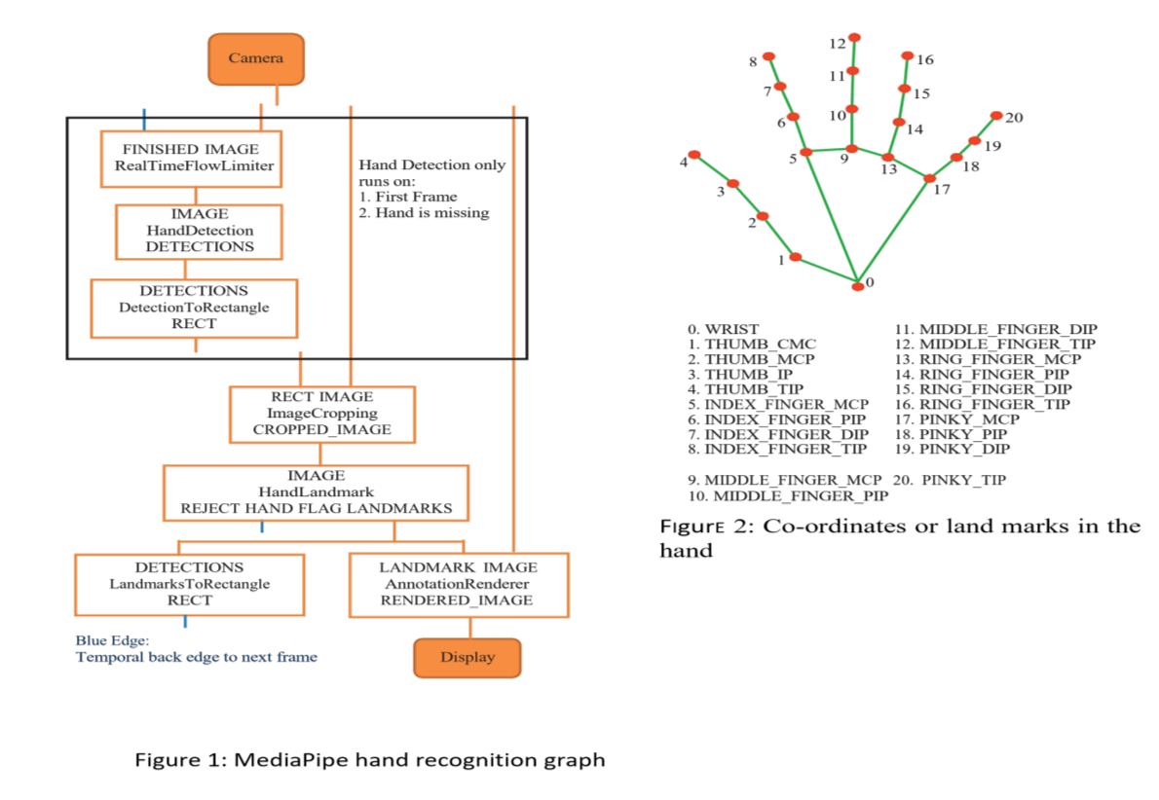

Above figure represents Use Case Diagram of the project and is a useful technique for identifying, clarifying, and organizing system requirements. It describes how a user uses a system to accomplish a particular goal. Use cases help ensure that the correct system is developed by capturing the requirements from the user's point of view.

3.2Activity Diagram
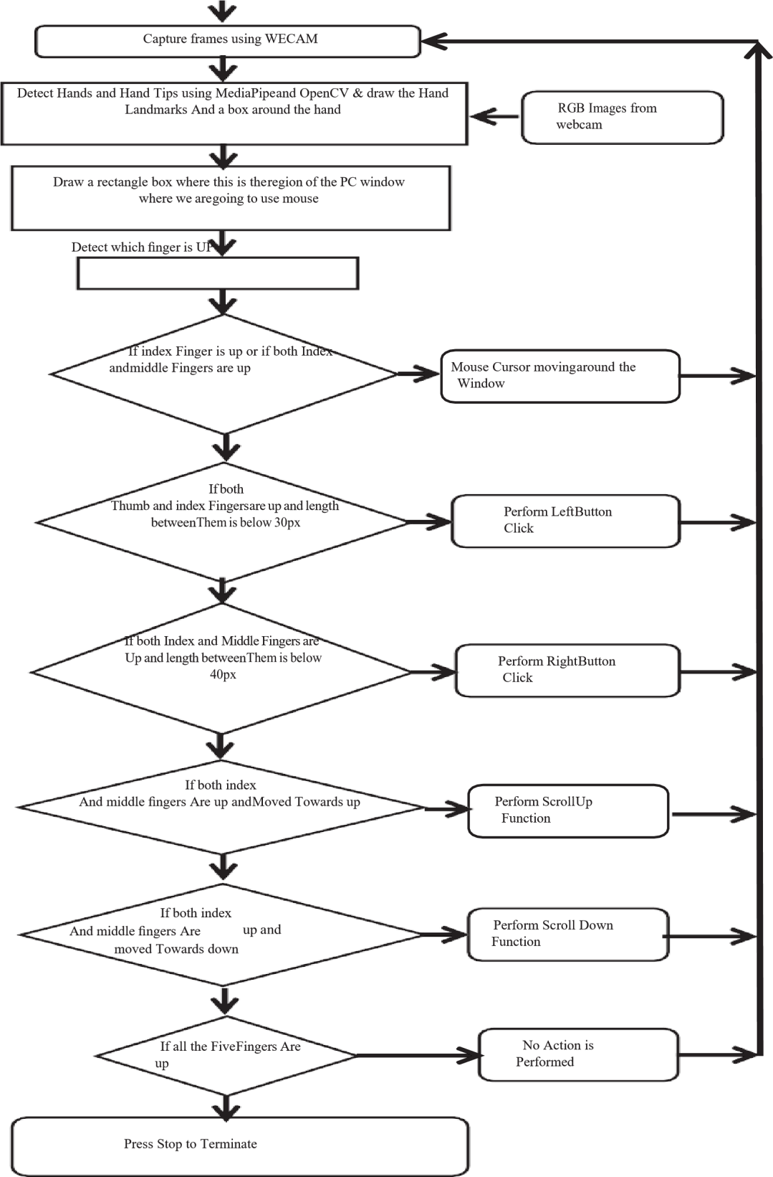

Above diagram describes the flow of control of a system. The flow can be sequential, concurrent or branched showing the overall functions of the system.

3.3 ER Diagram
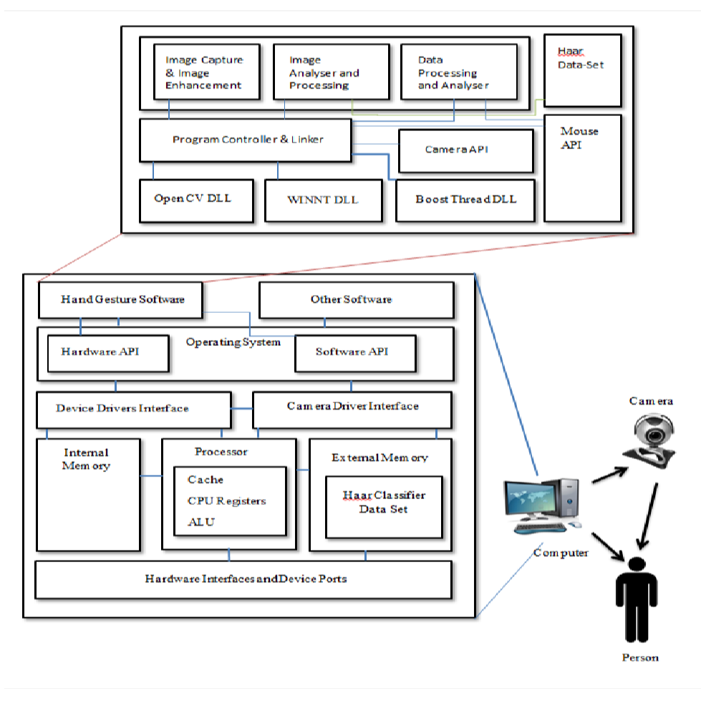

3.4Performance Analysis

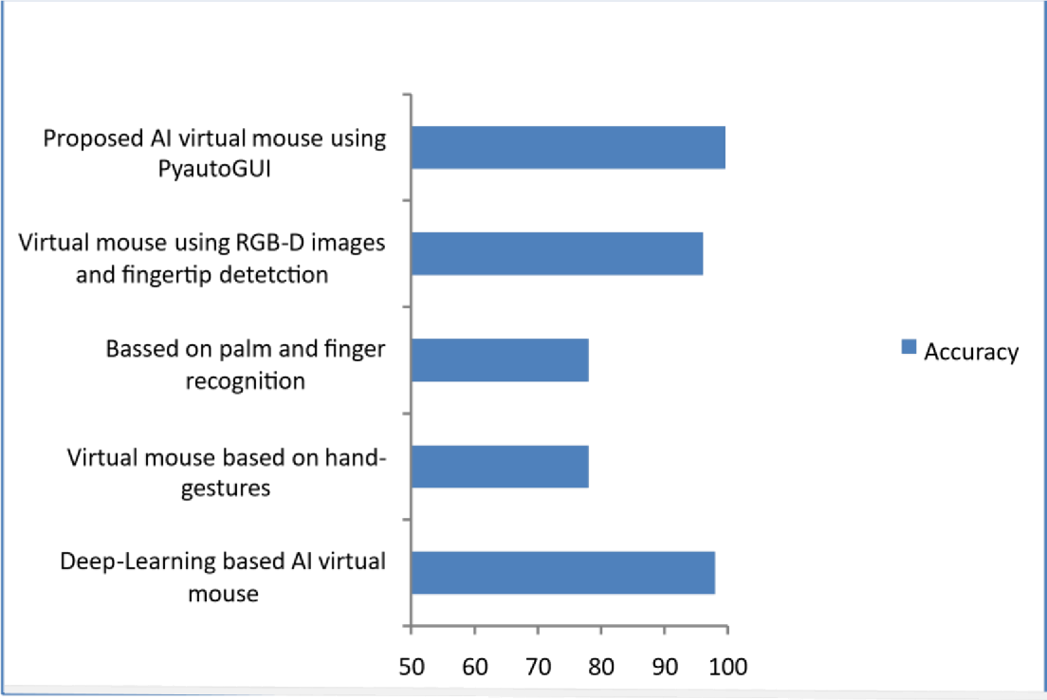
: Graph for comparison between different models

3.5METHODOLOGY:

The transformational method is used by the gesture-based virtual mouse system to translate the fingertip's coordinates from the camera screen to the full-screen computer window for operating the mouse. A rectangular box is generated in relation to the computer window in the camera zone where we move the mouse pointer around the window when the hands are identified and we determine which finger is capable of completing the specified mouse operation.

MODULES:

OpenCV -- The OpenCV library is used to analyze data from photos and videos, includingfaceandobjectdetection.
Media Pipe -- A framework called Media Pipe is a Google open- source framework that is applied in a machine learning pipeline.
PyAutoGUI –
In essence, PyAutoGUI is a Python software that runs on Windows, MacOS X, and Linux and allows users to imitate keyboard button pushes as well as mouse cursor movements and clicks. A Python package for cross-platform GUI automation for people is called PyAutoGUI. A Python automation module called PyAutoGUI may be used to click, drag, scroll, move, etc. It may be used to click precisely where you want. used to automate the control of the keyboard and mouse.
Math -- A crucial component created to deal with mathematical operations is the Python math module. It has always been there and is supplied with the default Python version. The majority of the mathematical functions in the math module are only thin wrappers for the C platform's equivalents.
3.6Custom Instructions
Here are some instructions tailored for you:
- **Download Project Files:** o Click on the link below to download the required project files. o Ensure that you save the files to a location you can easily access,
such as your Desktop or Documents folder.
- **Install PyCharm:** o If you haven't already installed PyCharm, download it from the official PyCharm website. o Follow the installation instructions provided on the website to set up PyCharm on your computer.
- **Set Up a New Project in PyCharm:** o Open PyCharm and select 'Open' from the welcome screen. o Navigate to the location where you saved the project files and
select the project folder to open it in PyCharm.
- **Install Required Libraries:** o Open the terminal in PyCharm (you can find it at the bottom of the PyCharm window).
  - Run the following commands to install the necessary libraries for the project:
    - pip install opencv-python - For computer vision tasks.
    - pip install mediapipe - For hand tracking.
    - pip install autopy - For controlling the mouse cursor.
    - pip install pyautogui - For additional mouse functions such as click, drag, scroll, and move.
- **Configure Project Settings:** o Ensure that the Python interpreter is correctly set up in PyCharm by navigating to 'File' > 'Settings' > 'Project: [your_project_name]' >
'Python Interpreter'. o Verify that all installed libraries are listed under the Python Interpreter settings.
- **Run the Project:**
  - Locate the main Python file that starts the application (e.g., `main.py`).in our case the names are 1.AiVirtualMouseProject 2.HandTrackingModule import this files from the location where you downloaded o Right-click on the file and select 'Run' to start the application.
  - follow the given instruction in readme.txt file to use the gesture-controlled virtual mouse.
- **Using the Virtual Mouse:** o Make sure your webcam is properly connected and functioning. o Place your hand in view of the webcam to start controlling the mouse cursor with gestures. o Refer to the project documentation for detailed information on available gestures and how to customize them.

CHAPTER – 4

IMPLEMENTATION

Code:

MAIN PROGRAM:-

AI VIRTUAL FUNCTION CODE
import cv2 import numpy as np
import HandTrackingModule as htm
import time
import autopy

# Parameters wCam, hCam = 640, 480 frameR = 100 # Frame reduction smoothening = 35

# Previous and current location pTime = 0 pLocX, pLocY = 0, 0
cLocX, cLocY = 0, 0

# Camera setup
cap = cv2.VideoCapture(0) # Ensure you're using the correct camera index cap.set(3, wCam)
cap.set(4, hCam)

# Hand detector
detector = htm.handDetector(maxHands=1) wScr, hScr = autopy.screen.size()

while True:
# 1. Find the hand landmarks success, img = cap.read() img = detector.findHands(img)
lmList, bbox = detector.findPosition(img)

# 2. Get the tip of the index and middle fingers if len(lmList) != 0: x1, y1 = lmList[8][1:] x2, y2 = lmList[12][1:]
x3, y3 = lmList[16][1:] # Ring finger tip

# 3. Check which fingers are up fingers = detector.fingersUp()

# 4. Only index finger: Moving mode

if fingers[1] == 1 and fingers[2] == 0 and fingers[3] == 0:
# 5. Convert coordinates x3 = np.interp(x1, (frameR, wCam - frameR), (0, wScr)) y3 = np.interp(y1, (frameR, hCam - frameR), (0, hScr))

# 6. Smoothen the values cLocX = pLocX + (x3 - pLocX) / smoothening cLocY = pLocY + (y3 - pLocY) / smoothening

# 7. Move mouse
autopy.mouse.move(wScr - cLocX, cLocY)
cv2.circle(img, (x1, y1), 15, (255, 0, 255), cv2.FILLED) pLocX, pLocY = cLocX, cLocY

# 8. Both index and middle fingers are up: Left-click mode if fingers[1] == 1 and fingers[2] == 1 and fingers[3] == 0: # 9. Find the distance between index and middle fingers length, img, lineInfo = detector.findDistance(8, 12, img)

# 10. Left-click mouse if distance is short if length < 40:
cv2.circle(img, (lineInfo[4], lineInfo[5]), 15, (0, 255, 0), cv2.FILLED)
autopy.mouse.click()

# 11. Index, middle, and ring fingers are up: Right-click mode if fingers[1] == 1 and fingers[2] == 1 and fingers[3] == 1: # 12. Find the distance between middle and ring fingers length, img, lineInfo = detector.findDistance(12, 16, img)

# 13. Right-click mouse if distance is short if length < 40:
cv2.circle(img, (lineInfo[4], lineInfo[5]), 15, (0, 0, 255), cv2.FILLED)
autopy.mouse.click(autopy.mouse.Button.RIGHT)

# 14. Frame rate cTime = time.time() fps = 1 / (cTime - pTime)
pTime = cTime cv2.putText(img, str(int(fps)), (20, 50), cv2.FONT_HERSHEY_PLAIN, 3, (255, 0, 0), 3)

# Display
cv2.imshow("Image", img) cv2.waitKey(1)

HAND TRACKING MODULE CODE

import cv2
import mediapipe as mp import time import math import numpy as np

class handDetector(): def __init__(self, mode=False, maxHands=2, detectionCon=0.5, trackCon=0.5):
self.mode = mode self.maxHands = maxHands self.detectionCon = detectionCon self.trackCon = trackCon

self.mpHands = mp.solutions.hands
self.hands = self.mpHands.Hands(static_image_mode=self.mode, max_num_hands=self.maxHands,
min_detection_confidence=self.detectionCon, min_tracking_confidence=self.trackCon)
self.mpDraw = mp.solutions.drawing_utils self.tipIds = [4, 8, 12, 16, 20]

def findHands(self, img, draw=True): imgRGB = cv2.cvtColor(img, cv2.COLOR_BGR2RGB) self.results = self.hands.process(imgRGB)

if self.results.multi_hand_landmarks: for handLms in self.results.multi_hand_landmarks: if draw:
self.mpDraw.draw_landmarks(img, handLms, self.mpHands.HAND_CONNECTIONS)

return img

def findPosition(self, img, handNo=0, draw=True): xList = [] yList = [] bbox = [] self.lmList = [] if self.results.multi_hand_landmarks: myHand = self.results.multi_hand_landmarks[handNo]

for id, lm in enumerate(myHand.landmark):
h, w, c = img.shape
cx, cy = int(lm.x * w), int(lm.y * h) xList.append(cx) yList.append(cy) self.lmList.append([id, cx, cy]) if draw: cv2.circle(img, (cx, cy), 5, (255, 0, 255), cv2.FILLED)

xmin, xmax = min(xList), max(xList) ymin, ymax = min(yList), max(yList) bbox = xmin, ymin, xmax, ymax

if draw:
cv2.rectangle(img, (xmin - 20, ymin - 20), (xmax + 20, ymax + 20),
(0, 255, 0), 2)

return self.lmList, bbox

def fingersUp(self):
fingers = [] # Thumb if self.lmList[self.tipIds[0]][1] > self.lmList[self.tipIds[0] - 1][1]: fingers.append(1) else:
fingers.append(0)

# Fingers for id in range(1, 5): if self.lmList[self.tipIds[id]][2] < self.lmList[self.tipIds[id] - 2][2]: fingers.append(1) else:
fingers.append(0)

return fingers

def findDistance(self, p1, p2, img, draw=True, r=15, t=3):
x1, y1 = self.lmList[p1][1:] x2, y2 = self.lmList[p2][1:]
cx, cy = (x1 + x2) // 2, (y1 + y2) // 2

if draw:
cv2.line(img, (x1, y1), (x2, y2), (255, 0, 255), t) cv2.circle(img, (x1, y1), r, (255, 0, 255), cv2.FILLED) cv2.circle(img, (x2, y2), r, (255, 0, 255), cv2.FILLED) cv2.circle(img, (cx, cy), r, (0, 0, 255), cv2.FILLED) length = math.hypot(x2 - x1, y2 - y1)

return length, img, [x1, y1, x2, y2, cx, cy]

def main(): pTime = 0 cTime = 0 cap = cv2.VideoCapture(0) # Try using 0 instead of 1 if not cap.isOpened(): print("Error: Could not open video capture.") return

detector = handDetector() while True: success, img = cap.read() if not success:
print("Error: Could not read frame from video capture.") break

img = detector.findHands(img) lmList, bbox = detector.findPosition(img) if len(lmList) != 0: print(lmList[4])

cTime = time.time() fps = 1 / (cTime - pTime) pTime = cTime

cv2.putText(img, str(int(fps)), (10, 70), cv2.FONT_HERSHEY_PLAIN, 3,
(255, 0, 255), 3)

cv2.imshow("Image", img) if cv2.waitKey(1) & 0xFF == ord('q'): break

cap.release()
cv2.destroyAllWindows()

if __name__ == "__main__": main()

REGISTER CODE

{% extends "base.html" %}
{% block content %}
<h2>Register</h2>
<form method="post">
{% csrf_token %}
{{ form.as_p }}
<button type="submit">Register</button>
</form>
<p>Already have an account? <a href="{% url 'login' %}">Login here</a>.< 11 {% endblock %}

DASHBOARD.HTML

{% extends "base.html" %}
{% block content %}
<h2>Register</h2>
<form method="post">
{% csrf_token %}
{{ form.as_p }}
<button type="submit">Regi<!DOCTYPE html>
<html>
<head>
<title>Dashboard</title>
</head> <body>
<h2>Welcome to your Dashboard, {{ user.username }}!</h2> <p>Here you can access your PyCharm files and customized instructions.</p>
<div>
<h3>Custom Instructions</h3>
<p>Here are some instructions tailored for you:</p>
<ul>
<li>**Download Project Files:**
<ul>
<li>Click on the link below to download the required project files.</li>
<li>Ensure that you save the files to a location you can easily access, such as your Desktop or Documents folder.</li>
</ul>
</li>
<li>**Install PyCharm:**
<ul>
<li>If you haven't already installed PyCharm, download it from the <a
href="https://www.jetbrains.com/pycharm/download/">official PyCharm website</a>.</li> <li>Follow the installation instructions provided on the website to set up PyCharm on your computer.</li>
</ul>
</li>
<li>**Set Up a New Project in PyCharm:**
<ul>
<li>Open PyCharm and select 'Open' from the welcome screen.</li> <li>Navigate to the location where you saved the project files and select the project folder to open it in PyCharm.</li>
</ul>
</li>
<li>**Install Required Libraries:**
<ul>
<li>Open the terminal in PyCharm (you can find it at the bottom of the PyCharm window).</li>
<li>Run the following commands to install the necessary libraries for the project:
<ul>
<li><code>pip install opencv-python</code>
- For computer vision tasks.</li>
<li><code>pip install mediapipe</code> - For hand tracking.</li>
<li><code>pip install autopy</code> - For controlling the mouse cursor.</li> <li><code>pip install pyautogui</code> - For additional mouse functions such as click, drag, scroll, and move.</li>
</ul>
</li>
</ul>
</li>
<li>**Configure Project Settings:**
<ul>
<li>Ensure that the Python interpreter is correctly set up in PyCharm by navigating to 'File' > 'Settings' > 'Project:
[your_project_name]' > 'Python Interpreter'.</li>
<li>Verify that all installed libraries are listed under the Python Interpreter settings.</li>
</ul>
</li>
<li>**Run the Project:**
<ul>
<li>Locate the main Python file that starts the application (e.g., `main.py`).in our case the names are
1.AiVirtualMouseProject 2.HandTrackingModule import this files from the location where you downloaded</li>
<li>Right-click on the file and select 'Run' to start the application.</li> <li>follow the given instruction in readme.txt file to use the gesture-controlled virtual mouse.</li>
</ul>
</li>
<li>**Using the Virtual Mouse:**
<ul>
<li>Make sure your webcam is properly connected and functioning.</li> <li>Place your hand in view of the webcam to start controlling the mouse cursor with gestures.</li>
<li>Refer to the project documentation for detailed information on available gestures and how to customize them.</li>
</ul>
</li>
</ul>
</div>
<a href="{% url 'list_pycharm_files' %}">View PyCharm Files</a> </body>
ter</button>
</form>
<p>Already have an account? <a href="{% url 'login' %}">Login here</a>.< 11 {% endblock %}

PYCHARM_FILES.HTML
<!DOCTYPE html>
<html>
<head>
<title>PyCharm Files</title>
</head>
<body>
\<h2>PyCharm Files</h2>
<ul>
{% for file in files %}
<li><a href="{% url 'download_pycharm_file' file %}">{{ file
}}</a></li>
{% endfor %}
</ul>
<a href="{% url 'dashboard' %}">Back to Dashboard</a> </body> </html>

CHAPTER – 5

SYSTEM TESTING

5.1 Types of Tests
Testing is the evaluation of the software against the requirements gathered from users and system specifications. For the Hand Gesture Controlled Virtual Mouse system, testing identifies critical defects, flaws, or errors in the application code that must be addressed. It also evaluates how well the system functions according to its intended purpose, ensuring the quality of the virtual mouse experience.

5.1.1 Unit Testing
Unit testing refers to testing specific functions and modules of the gesture-controlled virtual mouse system. It helps verify that each gesture-related function, such as hand detection or cursor movement, works as expected. This testing phase ensures that individual components like hand gesture recognition, click detection, and cursor movement logic operate correctly. By identifying failures in the algorithm or logic early on, the quality of each component is enhanced.

5.1.2 Integration Testing
Integration testing is an extension of unit testing where different modules of the system are combined and tested as a whole. In the context of the virtual mouse, this involves testing the integration between gesture recognition and mouse functions, ensuring that hand movements translate correctly into mouse actions such as moving the cursor, clicking, and dragging. Integration testing helps identify problems that may occur when combining gesture detection with mouse control mechanisms. For this project, each module, such as gesture tracking and cursor control, has undergone integration testing to ensure they function smoothly together.

5.1.3 System Testing
System testing evaluates the overall performance and behavior of the Hand Gesture Controlled Virtual Mouse as a complete system. It ensures that the entire system— comprising gesture detection, mouse control, and user interaction—works as specified. This testing phase includes validating that the system responds correctly to different gestures, interacts seamlessly with the operating system, and uses system resources efficiently. System testing is typically performed at the end of each major feature and continuously refined to ensure that the system meets all specifications and objectives.

CHAPTER – 6

RESULTS

REGISTER PAGE:

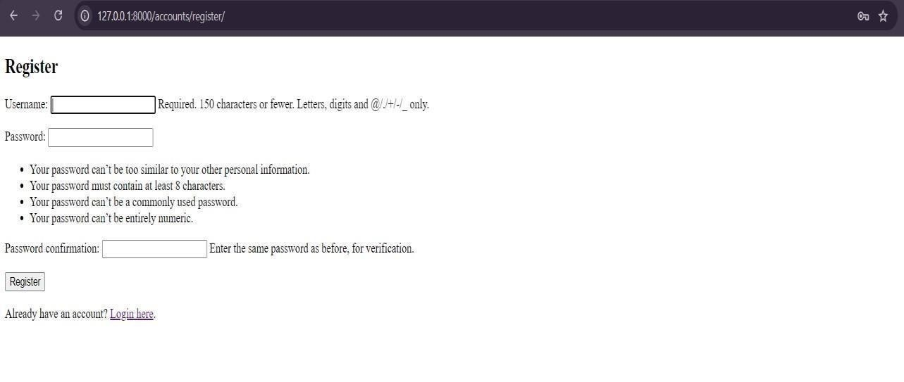

LOGIN PAGE :
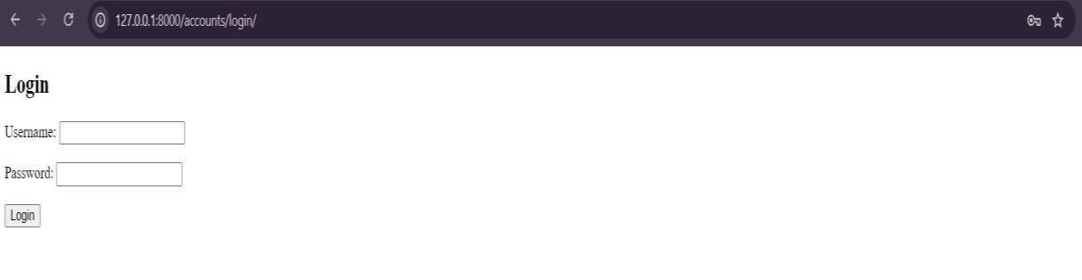

Dashboard:
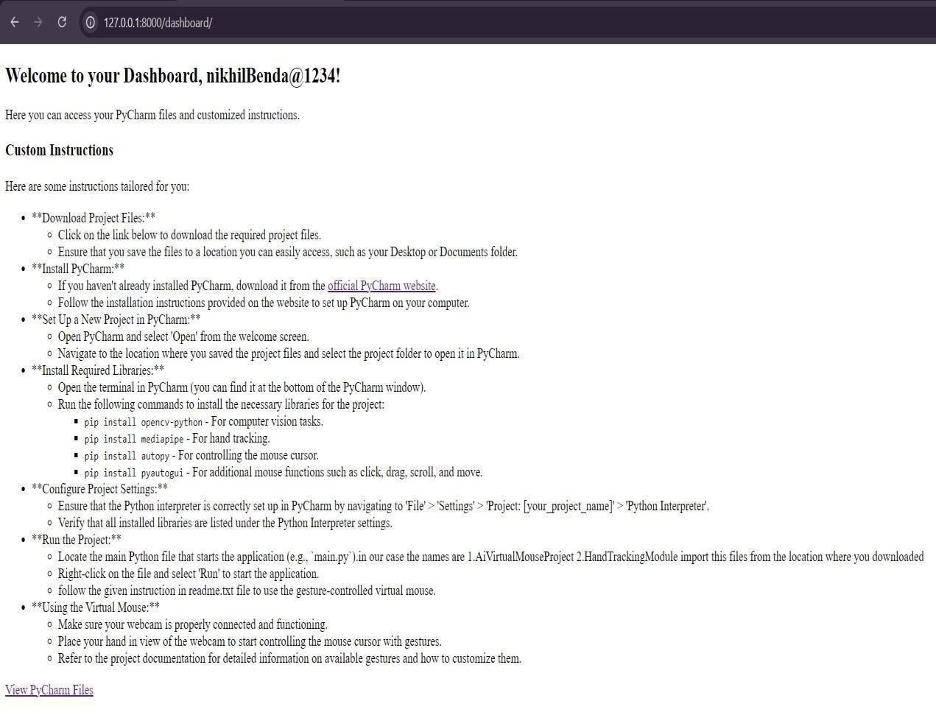
PY_CHARM FILES LIST:

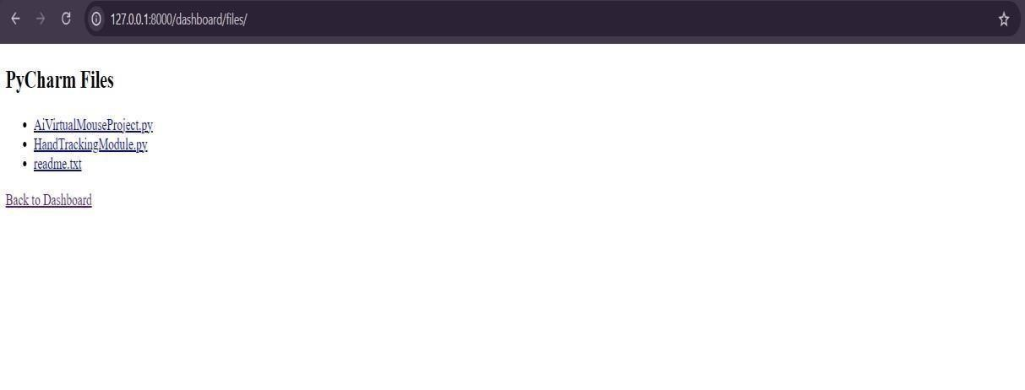

\
HAND GESTURES:
1.Move:
- Gesture: Open palm or index finger extended.
- Result: As the hand or finger moves in the air, the virtual cursor tracks the movement across the screen.
This allows the user to move the cursor to any desired location on the screen.
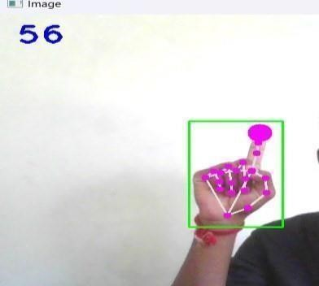
- Select:
  - Gesture: Pointing or pinch gesture (index finger and thumb brought together).
  - Result: The virtual mouse cursor moves to the selected item on the screen, and when the gesture is held for a certain time, it triggers a click action, selecting the item.
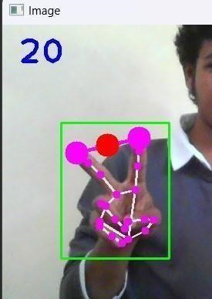
- Right-Click:
  - Gesture: Similar to the "peace" sign gesture or a specific hand shape (e.g., thumb touching the middle finger).
  - Result: The system recognizes the gesture and performs a right-click action, often bringing up a context menu at the location of the cursor.
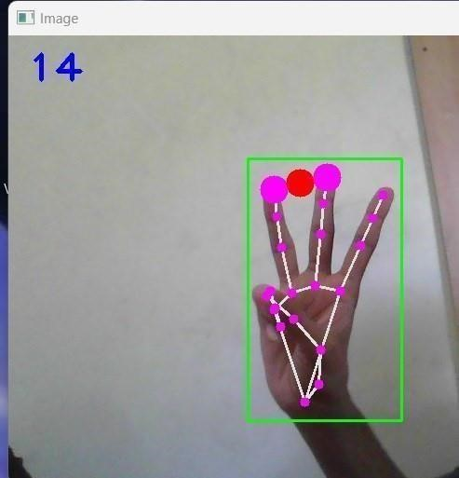
WORKING:
MOVE
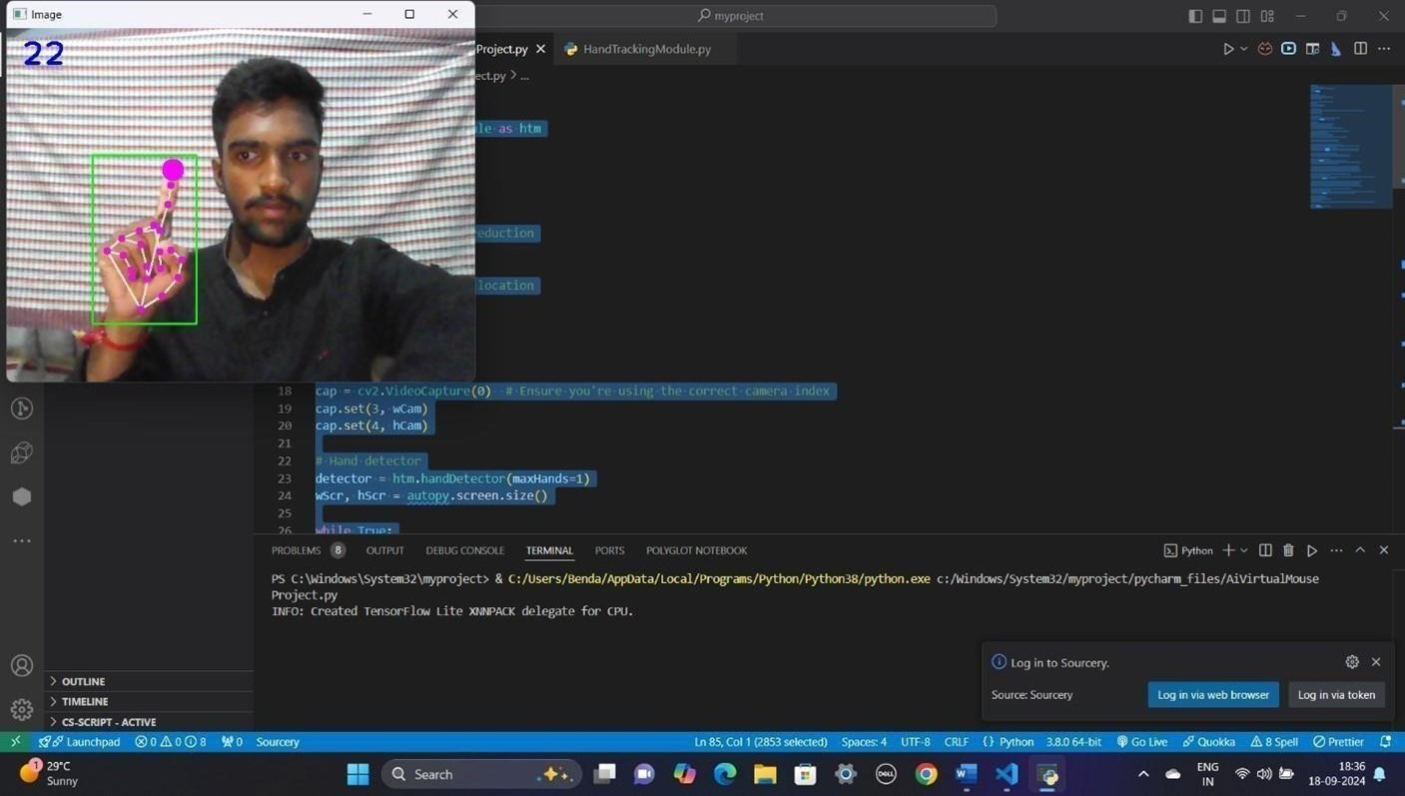

SECLECT:

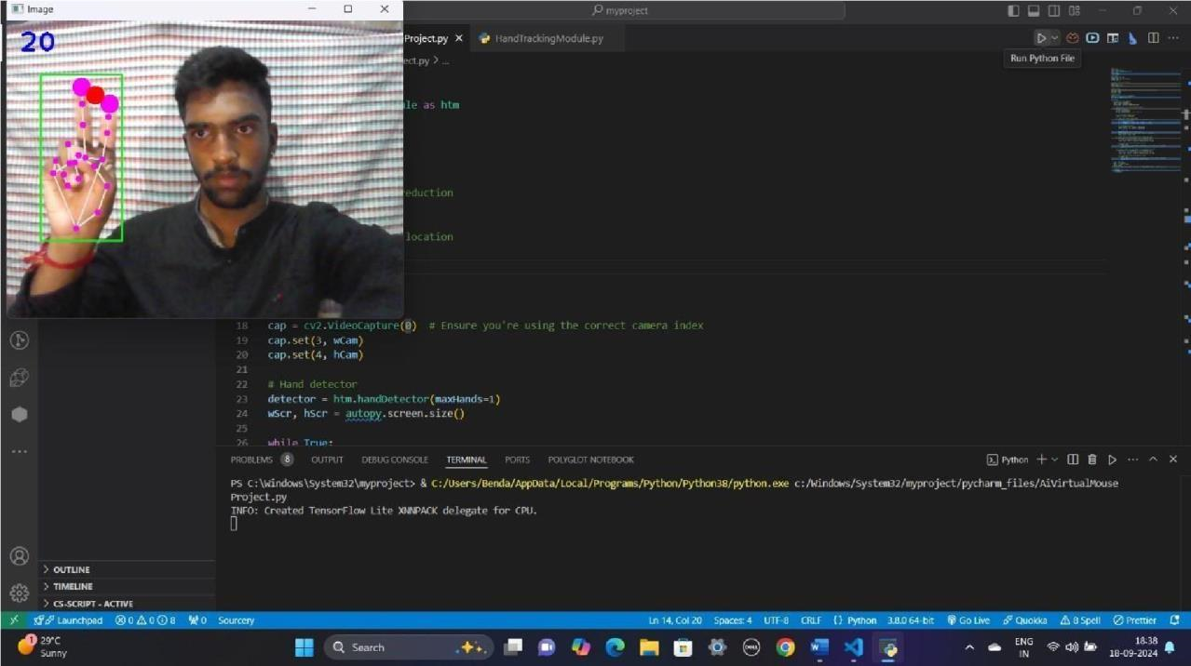
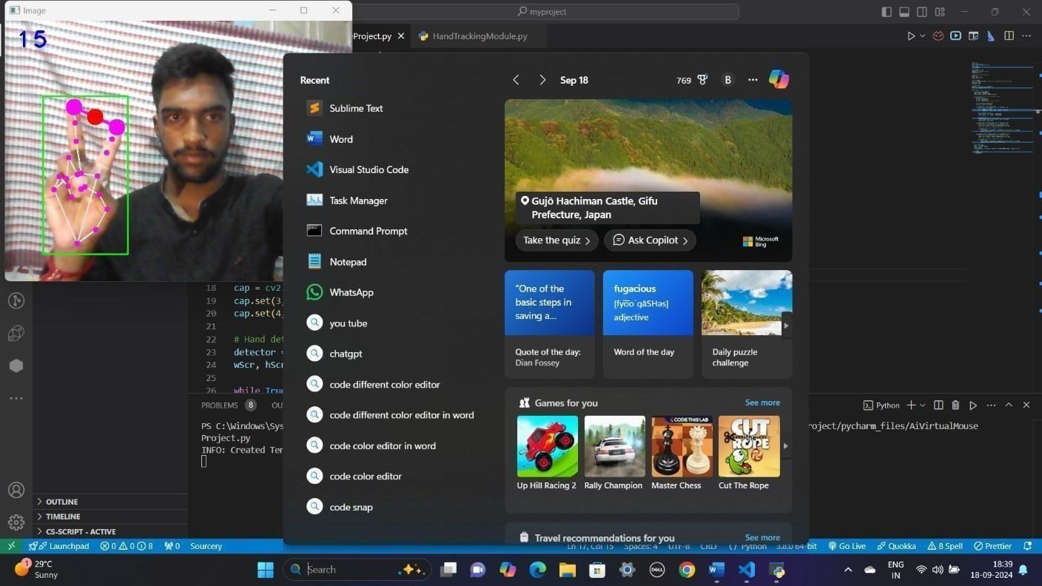

RIGHT-CLICK:

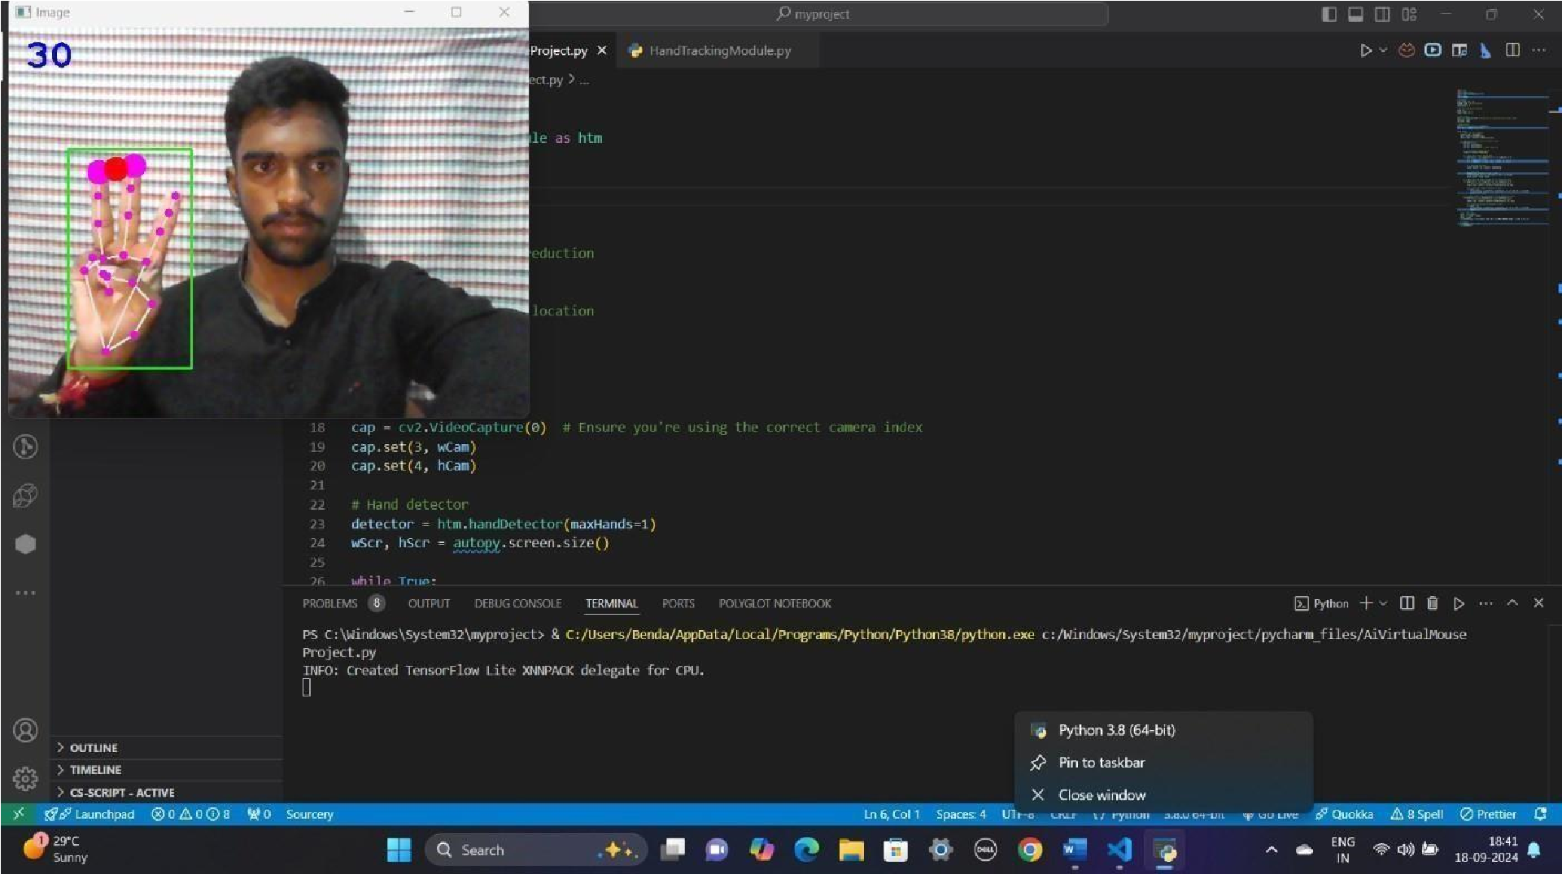

CHAPTER – 7

CONCLUSION

Conclusion:
The virtual mouse system's main objective is to eliminate the need for a hardware mouse by allowing users to manage mouse cursor functions with hand gestures instead. The described method can be used with a webcam or an integrated camera that analyses frames to recognise hand movements and hand tips and execute specific mouse actions. The model has some shortcomings, including some difficulties with dragging and clicking to select text and a slight loss of precision in right-click mouse capabilities. We will now concentrate on improving the fingertip identification algorithm in order to overcome these limitations.

The gesture-controlled virtual mouse system demonstrates a significant advancement in user interaction technology by utilizing hand tracking to facilitate intuitive and hands-free control. Through effective gesture recognition and seamless integration with system APIs, the system offers a practical and efficient alternative to traditional input devices.

While current implementations provide a solid foundation, ongoing improvements in gesture accuracy, system responsiveness, and user feedback will further enhance its usability and expand its potential applications.

CHAPTER – 8

REFERENCES

References:
- S. U. Dudhane, “Cursor control system using hand gesture recognition,” IJARCCE, vol. 2, no. 5,
2013. View at: Google Scholar.
- Rao, A.K., Gordon, A.M., 2001. Contribution of tactile information to accuracy in pointing movements.
Exp. Brain Res.138,438–445.
https://doi.org/10.1007/s002210100717
- Chaihanya C, Lisho Thomas, Naveen Wilson, and Abhilash SS in 2018 proposed “Virtual
Mouse Using Hand Gesture” where the model detection is based on colors. but only few mice function are performed.
- www.computervision.zone www.openai.com
- https://github.com/
- Computerzone.com

